Vietnam Budget 2012 - 2013

Table of Contents
Foreword
Chapter I. Outcomes of the 2012 Socio-economic and Budget Plans
1. Global Economic Overview 2012
2. Domestic Socio-economic Developments 2012
3. The 2012 Budget Plan’s Performance Review

Chapter II. Socio-economic Development and Budget Plans 2013
1. Economic Outlook 2013
1.1 Global Economic Outlook 2013
1.2 Domestic Economic Outlook 2013
2. Government Budget Plan 2013
2.1. Master Objectives 2013
2.2 Plan of Government Revenues 2013
2.3 Plan of Government Expenditures 2013
2.4 Government Budget Balance 2013

Chapter III. The 2013 Budget Plan’s Developments
1. The 2013 Budget Plan’s Developments
1.1 Fiscal Measures Performance to ease Firms’ Production and Business, to support Markets and to tackle Bad Debts
1.2 The 2013 Budget Plan’s 4 month performance
2. Challenges need solved to the 2013 budget plan execution
3. Major Measures to maintain budget balance and best fulfillment of the 2013 budget plan.

Chapter IV. Appendices of Economics and Fiscal Indicators
1. Key Socio-economic Indicators
2. Major Budgetary Lines
3. Tables and Graphs
Abbreviations
References
SOCIO-ECONOMIC AND BUDGET APPENDICES

1. Budget index
1.1 General government budget balance
1.2 General government revenues by sector
1.3 General government expenditures by sector
1.4 Plan of central government budget's expenditures by sector fy2013
1.5 Plan of expenditures of ministries, central government agencies by sector and by central government budget's spending assignment fy 2013
1.6 Plan of revenues and expenditures of provinces and cities under the central government fy 2013
2. Socio-economic index
2.1 Some general indicators
2.2 Gross domestic product in real term by economic sectors
2.3 Imports and exports by commodities
2.4 Consumer price index (month on month)

Tables
Table 1: Public debt analysis: Gross debt as a share of GDP
Table 2: Global economic growth 2012 Review
Table 3: Global CPI 2008-2012
Table 4: Socio-economic indicators 2009-2013
Charts
Chart 1: Global unemployment trends 2000- 2012
Chart 2: GDP, CPI growth
Chart 3: Manufacturing sector, agriculture sector and services growth
Chart 4: Growth of exports value over period 2009-2012
Chart 5: Consumer Price Index in 5-ASEAN countries
Chart 6: Global GDP growth
Chart 7: GDP growth in selected countries
Chart 8: Global CPI deviation
Chart 9: Fiscal deficit outlook in selected countries
Chart 10: Fiscal deficit Outlook in selected ASEAN countries
Chart 11: Vietnam public debt outlook 2013

ABBREVIATIONS
1. ADB: Asian Development Bank
2. CPI: Consumer Price Index
3. DEC: Decision
4. CPV: Communist party of Vietnam
5. EU: European Union
6. GDP: Gross Domestic Products
7. Gov: Government
8. GSO: General Statistics Office
9. IFS International Financial Stastistics
10. IIP: Index of Industry Production
11. IMF: International Monetary Fund
12. ILO: International Labour Organisation
13. MPI: Ministry of Planning and Investment
14. MoF: Ministry of Finance
15 NSNN: general government budget
16. NA: National Assembly
17. OECD: Organisation for Economic Cooperation and Development
18. PAR: Program of Comprehensive Administrative Reform
19. PM: Prime minister
20. PRSC: Poverty Reduction Support Credit
21. Rep: Report
22. Res: Resolution
23. SOEs: State-owned enterprises
24. KTXH: Socio-economic
25. WB: World Bank
FOREWORD
With effort to enhance public transparency in the management and spending State budget funds, and also implementation of the provisions of the Anti-corruption Law, the Law on Thriftiness and Prevention of Wasteful Practices, Anti-corruption Action Plans, Practices of Thriftiness and Prevention of Wasteful of the Government, in line with the requirements for global economic integration, the Ministry of Finance has compiled and published “Vietnam budget 2012-2013”, information in the book are up-to-date and fiscal data which have been approved by the National Assembly. The book is organized into 4 sections:
- Chapter I. Outcomes of the 2012 Socio-economic and Budget Plans
- Chapter II. Socio-economic Development and Budget Plans 2013
- Chapter III. The 2013 Budget Plan’s Developments
- Chapter IV. Appendices of socio-economic and budget indicators
If readers have any difficulties while using this book, please do not hesitate to put any comments or to contact the Ministry of Finance (the State Budget Department). All comments are welcome regardless of those of organizations, researchers, or individuals if better improve public disclosure of the budget and public finance./.
Hanoi. June 2013

Chapter I. Outcomes of the 2012 Socio-economic and Budget Plans
1. Global Economic Overview 2012
Latest economic outlooks by many global economic organizations show that the 2012 global economy remains difficult and potentially risky against public debts, low level of employment, inflation pressure, economic slowdown, financial crisis, natural disasters and political turmoils scattering on worldwide-scale.
Potential public debt crisis continued to threaten and outbreak. The debt crisis commenced from Greece (2010) then it rapidly spread over the Eurozone i.e Spain, Portuguese, Sip Republic and Italy in 2012. Leading economies such as the U.S and Japan etc., have been struggling so far with large budget deficits and overwhelmingly outstanding public debts caused by low budget revenues and high demand for social benefits and social security for the same excuse of economic slowdown. Emerging economies, India and China, are slowing down their uptrend. Debt crisis in developed countries was and will be the main cause to global economic recovery.
Table 1: Public debt analysis: Gross debt as a share of GDP %
Country | 2008 | 2009 | 2010 | 2011 | 2012
France | 68.2 | 79.2 | 82.3 | 86.0 | 90.3
Greece | 112.5 | 129.3 | 147.9 | 170.6 | 158.5
Italy | 106.1 | 116.4 | 119.0 | 120.8 | 127.0
Japan | 191.8 | 210.2 | 216.0 | 230.9 | 245.4
The United States | 75.5 | 89.1 | 98.2 | 102.5 | 106.5
Source: IMF 2013, World Economic Outlook, April 2013
The 2012 world economic growth remained minusculy improved. A great number of World Economic Outlooks (2012) reviewed and consented that the global economic was not improved significantly, even reduced 0.5 percentage points over year 2011 owing to some negative elements. First, the slowdown economic growth of global economic locomotives such as the United States of America, Eurozone, Japan, China and India. In addition, increasingly socio-economic turmoils, financial crises, monetary and trade wars (or even risks of double-dip economic recession) were main drivers. Some international financial institutions, such as WB and IMF, constantly adjusted the world's GDP growth projections through their WEOs publications. In a recent WEO, the IMF has reestimated the global growth to 3.2 percent from 4.5 percent of her preceding report, which was much lower than that of 5.4 percent of pre-crisis year 2007’s.

Table 2: Global economic growth 2012 Review %
Country | 2008 | 2009 | 2010 | 2011 | 2012
Global growth | 2.8 | -0.6 | 5.2 | 4.0 | 3.3
Developed economies | 0.1 | -3.5 | 3.0 | 1.6 | 1.2
New emerging and developing economies | 6,1 | 2.7 | 7.6 | 6.4 | 5.1
Source: IMF, WEO2012/2013, April+October 2012, April2014
Unemployment constantly remained high and trended in a fluctuated pathway. Global Employment Trend 2013 by The International Labor Organisation (ILO) represents a constantly high unemployed line of the world employment at around 6 percent owing to the dip financial crises and economic downturns. Particularly, the developed countries witnessed a level of 8 percent, even more the US and Australia 9 percent and highest in Greece 21.9 percent. Moreover, a rapid growth of new participating labor forces in the world's population pushes up more pressure on job creation and economic growth .
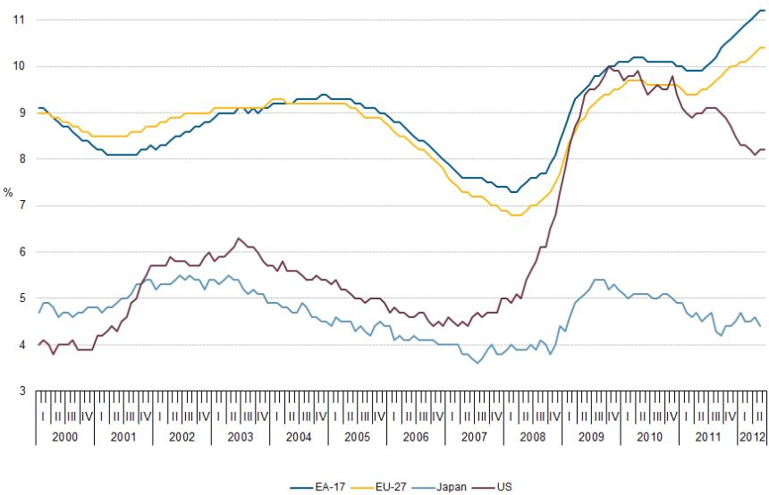
Chart 1 : Global unemployment trends 2000- 2012

Note: EA-17:17East Asian economies; EU27: 27economies in Eurozone. Source: ILO2012, Global Employment Trends 2012, April 2012.

Global inflation pressure of goods and services and economic slowdown have been decreased in 2012. General price pressure declined owing to a decrease in purchasing power of the gross demand and stagnation of production and consumption postpone. However, natural disasters caused crops production losses in dominant farming countries i.e. China, Australia and speculations by seasonal investors resulting in food price hikes in last quarter of 2012. Besides, oil price tended to increase due to high demand for energy from Asia and expectation of oil production cuts owing to political disruptions in Middle East and North Africa. Moreover, having tackled economic downturns, a number of countries have executed expansion fiscal and monetary policies. Those measures, in one hand, helped curb domestic demand’s downward trend, and on other hand, they can generate new money inflows to developing economies, pressing pressure on foreign exchange regime and inflation risks.

Table 3: Global CPI 2008-2012 %
Country | 2008 | 2009 | 2010 | 2011 | 2012
World | 6.05 | 3.1 | 4.1 | 3.5 | 3.25
Developed economies | 3.4 | 0.1 | 1.5 | 2.7 | 2.0
New Emerging and developing economies | 9.2 | 5.1 | 6.0 | 7.2 | 5.9
Source: IMF 2012/2013, World Economic Outlooks, October 2012 and April 2013

In summary, the 2012 world economic have experienced a great number of difficulties. Economic growth and trade outcomes were lower than expected projections, unemployment was not been improved, risks of debt crisis continually strained macroeconomic stability and financial markets. Therefore, enhancing fiscal disciplines, budget transparency and a comprehensive legal system of finance – banking which stabilise the economy are now put on the top priorities of many countries. In addition, because of policy’s consequence and fiscal space limits, overwhelming effects of macro-economic policies to tackling difficulties is therefore contracted. It is expected that economic difficulties will be prolonged in 2013 or next few years.
2. Domestic Socio-economic Developments 2012
Generally, the 2012 key socio-economic targets regarding inflation restrain and macro-economic stability principally have been met. Economic growth though fails to meet the planned target, however in regard of the context that the government focuses on inflation curbing and economy restructuring during global downturns, such the 2012 growth would be encouraged. The 2012 GDP gained 5.03 percent (was set 6-6.5 percent in the plan); annual exports value attained 18.2 percent (was set 13.0 percent in the plan); inflation was restrained at 6.81 percent; credit interest declined; foreign reserves increased; foreign exchange regime kept stable; principally, macroeconomic conditions have been stabilised; manufacturing index was gradually restoring its inclining trend; good inventories index slightly decreased; agriculture and services sectors has been seen a good growth; socio-political situation kept stable, defense and public security sustained, social security was paid enough attention to.
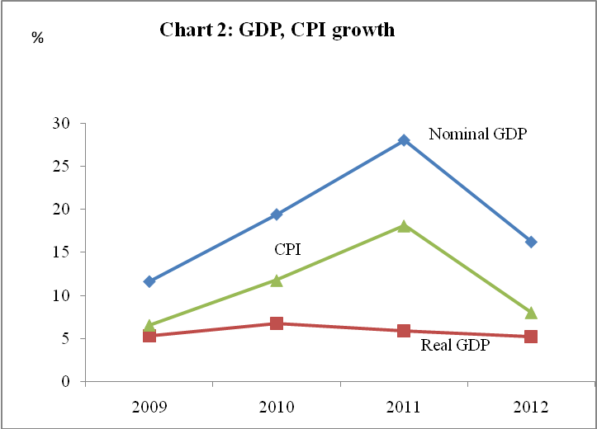

Source: GSO, Vietnam Stastical yearbooks. Those 2012 statistics are on the the government’s supplementation report to socio-economic review at the session V of the National Assembly Term XIII (May 2013)

Manufacturing and construction sectors have been seen a good growth and become key determinants of the economic growth in 2012. Being pressing down by general economic slowdown to 4.52 percent in 2012 but averaged at approximately 6.0 percent over 2008-2012, the sectors remain a growth locomotive of the economy. The government continues to direct and spares resources for the manufacturing sector development so as to expand the industrial production and dip-investment, to enhance productivity and product's competitiveness of the sector, to search new markets for processing industry. In 2012, processing industry stays its leading role among the whole manufacturing sector's growth.
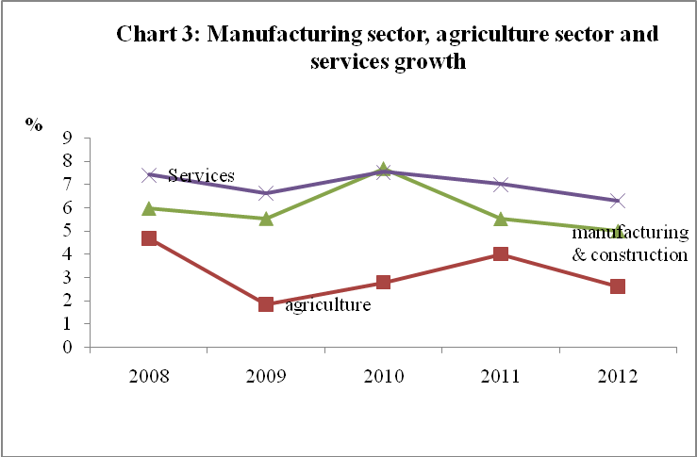

Source : GSO, Vietnam Stastical yearbooks. Those 2012 statistics are on the the government’s supplementation report to socio-economic review at the session V of the National Assembly Term XIII (May 2013)

Services sector and export sector have stayed recovery and growing over past years. Services sector performs a sound growth, gaining 6.42 percent in 2012. Regarding export and import activities, exports turnover though grew less than that of last year (18.2 percent over 34.2 percent in 2011), stays greater that that of imports value growth (6.6 percent). The first time since 1993, the exports-import balance has been positive with trade gap of USD 780 million. Major drivers were the complicated evolution of global economy, particularly debt crises in the Eurozone drove the global growth down, affecting Vietnam’s export activities. For instance, the growth of imports value of developed economies, especially European importation, stayed around 4 percent in 2012 or 1.9 percentage points lower than that of year 2011. Further more, fragile developments of strong currencies wars would vulnerate the situation of Vietnam trade perspectives in 2012 even worse.
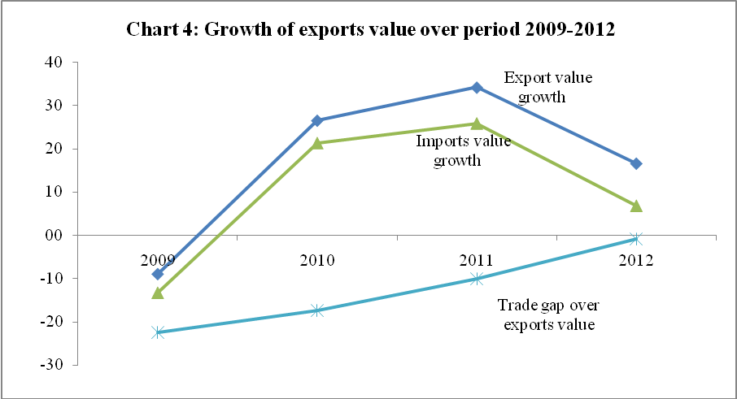

Source : GSO, Vietnam Stastical yearbooks. Those 2012 statistics are on the the government’s supplementation report to socio-economic review at the session V of the National Assembly Term XIII (May 2013)

Domestic consumer price index (CPI) was relatively improved in relation to that of year 2011. Thanks to the nation’s effort made to the NA's resolutions, the 12 month CPI was controlled at 6.81 percent, a sizeable reduction if compared to the year 2011 (18.13 percent). This figure, however, was still higher than that of new emerging countries (5 percent) and the average of 5 ASEAN countries (3.8 percent), for example Indonesia 4.3 percent, Thailand 3.0 percent, Malaysia 1.7 percent, Vietnam 6.81 percent and Philippines 3.1 percent.
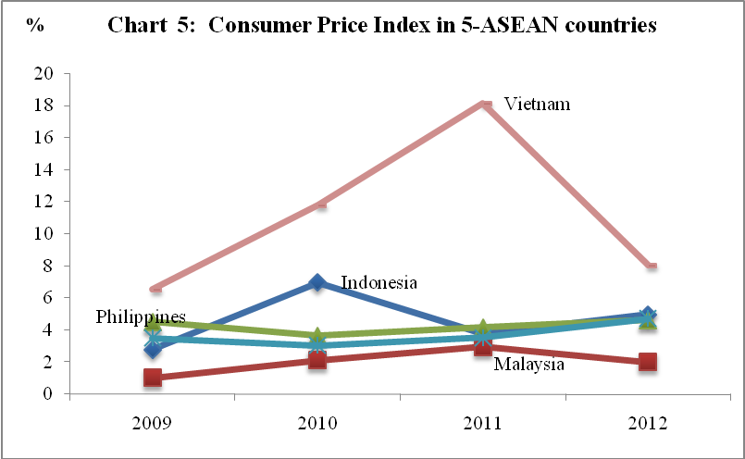

Source: WEO2013, April 2013, GSO, Vietnam Stastical yearbooks. Those 2012 statistics are on the government’s supplementation report to socio-economic review at the session V of the National Assembly Term XIII (May 2013)
Nevertheless, the domestic economy remains challengeable in short term, medium term and long term. Before hand, macroeconomic stability remains unsteady while the domestic economy is vulnerable against internal and external shocks. Contrast to that of past years, major economic indicators i.e. economic growth, inflation, currency power, public debt outstanding have been improved not much, and their outcomes are lower than sound regional countries and world economies. Besides that, high openness degree of the economy associated with negative externalities which are even advanced, the economy’s resistance is weaker and vulnerably and weakened than ever. In addition, whether Vietnam’s economy can sustain or not, it depends on the success or failure of the economy restructure, in which 3 major polls are manufacturing sector, agriculture and services. Moreover, poor infrastructure’s quality and human resources are the principal shortcomings but able to resolve which requires suitable directing policies, time and financial resources.
3. The 2012 Budget Plan’s Performance Review
3.1 Major fiscal policy’s objectives
Having settled in the Party and the National Assembly's resolutions on the Socio-Economic Plan for year 2012, the Budget Plan for year 2012 has drawn major objectives, such as positivity of the 2012 budget formulation, inflation curbing, macroeconomic stabilisation, human resource-tartgeted orientation, wages and salaries reform, social security policies, national defense and public security insured, nation's finance security in new circumstances. At the Session 2 of the 13th National Assembly, the Resolution on the 2012 budgeted plan has been approved with major budget indicators, of which total general government revenue reached at VND 740.5 trillion, total general government allocated at VND 903.1 trillion. The government budget balance was pre-set at minus 140.2 trillion dong (or 4.8 percent of GDP) on the basis of exerting VND 22.4 trillion of the 2011’s brought forward revenues.
The above internal and external socio-economic developments have considerably affected the government budget execution for year 2012. Nonetheless, a wide range of fiscal policy's supporting measures have been adopted to favor firm's production and business, to support markets i.e. tax reduction, tax payment postpone or even tax exemption. On the other hand, the government continues to enforce tax administration, preventing tax frauds, tax avoidance to increase the tax collection’s effectiveness.
3.2 The 2012 budget plan’s government revenues outcomes
3.2.1 Adoption of fiscal aiding measures to firms’ business and production
Having exercised the NA’s Resolutions 08/2011/QH13 dated 6 August 2011 and 29/2012/QH13 dated 21 June 2012 promulgated some extra tax measures to ease firms and private business’s strains, and the Government’s Resolution 13/NQ-CP dated 10 May 2012 on supporting measures to firms, markets etc., about 13.3 trillion dong of tax exemption, tax delay and tax concession shifting to year 2013 and other revenues was used to aid markets and firms. Of which,
(i) 1,627 billion dongs was of tax was exempted, including approximately 81 billion of lumpsum tax and corporate income tax; 1,534 billion dongs of personal income tax and 12,7 billion dongs of license tax imposed on family households who doing fishing and making salt.
(ii) 2,473 billion dongs was of tax cuts and land rents, including 30 percent (1,709 billion dongs) of corporate income tax's payables in 2012 for small and medium enterprises, labour-intensive firms; and 50 percent (234,2 billion dongs) of personal income tax payables on securities trading activities; 50 percent of land rents payables (530 billion dongs).
(iii) 9,198 billion dongs was of tax payment delay and land user right assignment’s revenue, including 5,021 billion dongs of VAT incurred in June 2012 and 4,177 billion dongs of land user right assignment’s revenue for project investors who suffering financial problems with max duration of 12 months for year 2012.
In short, those measures of tax exemption, tax payment delay and other revenue cut-offs have aided firms and generated financial resources for them to restabilising their production-business, easing difficulties for production-business and maintaining a reasonable economic growth.
Major achievements of revenues collection can be presented as follows:
Total general government revenues were set at 740.4 trillion dongs in the budget plan. Having tackled economic troubles of year-end period with high determination, total government budget was reached at 743.19 trillion dongs, or 0.4 percent higher than the plan’s; domestic revenues (subtracted land user right assignment’s revenue and state-owned house sales) attained 14.3 percent of GDP. In details:
3.2.1 Domestic revenue was budgeted at 494.6 trillion dongs in the 2012 budget, the outcome was 467.43 trillion dongs, or 94.5 percent of the budgeted number, of which estimate of land user right assignment revenue attained 45,109 billion dongs, exceeding 21.9 percent over the plan.
Even though realty market’s crisis in 2012, but right revenue management and supervision of those tax payment delay on due at year-end under the government resolutions at some main large localities (Ha Noi and Ho Chi Minh city etc.,), the budget revenues was collected at 21 trillion dongs within 3 year-end months of land user right assignment revenue, an equivalence of 90 percent of 9 preceding months, totaling up 45.1 trillion dongs of this land revenue, exceeding 21.9 percent over the plan’s. If subtracting this land revenue, the domestic revenues reached 422,321billion dongs, decreasing 35,279 billion dongs (or 7.7 percent) over the plan’s.
Major drivers for lower domestic revenues can be found, such as slower economic growth than the plan’s, production and business slowndown, slower products consumption, high stocks of goods, and a large number of collapsing firms. Besides that the fiscal measures supporting firms and markets also affected the domestic revenues. In reality, most of the direct revenues from production-business in 2012 were lower than budgeted. For example, revenues from state sector attained 92.3 percent of the plan’s target, revenues from foreign-invested sector reached 84.8 percent of the plan’s target and revenues from non-state sector met 84.2 percent of the planned target.
3.2.2 Oil revenues were budgeted at 87 trillion dongs on the basis of production output of 14.68 million tons, priced at USD 85 per barrel. Annual revenue’s outcome reached 140,107 billion dongs, a rise of 60.0 percent (53,107 billion dongs) compared with the budgeted number with realised oil price of 116.5 USD/barrel, 31.5 USD higher than the projected oil price, and oil production of 15.28 million tons, an increase of 530 thousand tons over the plan.
3.2.3 Net revenue from export and import activities was budgeted at 153.9 trillion dongs, which was based on the total revenues from exporting and importing activities of 223,9 trillion dong and refund of value added tax of 70 trillion dongs. However, total realized customs revenues reached 197,828 billion dongs, an equivalence of 88.4 percent of the plan’s, after deducting 70 trillion dongs of VAT refunds as regulated, the net customs revenues was 127,828 billion dongs, reaching 83.1 percent (or a gap of 26,072 billion dongs) of the plan’s. Main drivers caused the gap can be named (i) imports values rate items reduced, an averaged reduction of 6.1 percent (particularly the high-valued imports i.e, automobiles, alcohol, beauty care products, mobiphones etc., which carried high tariff rates was lowered); associated with other restriction regulations on these imports…(ii) realised tariff rates on some imported items was adjusted lower than the plan’s, for instance, rate of imported petrol 12 percent lower than 20 percent of the plan, rate of exported coal only 10 percent compared with 20 percent of the plan… so as to support domestic production.
3.2.4 Revenue from grants was budgeted at 5 trillion dongs, realised at 7,825 billion dongs in 2012, an increase of 56.5 percent (or 2,825 billion dongs) compared to the budgeted number owing to an extra grants from national security programs, and parts of being switched from offbudgets.

In short, in the spirit of drastic efforts, the 2012 realised budget revenues reaches the National Assembly's approved target (even excessively 0.4 percent), in which structure of revenues changed, such as domestic revenue reduces 27,170 billion dongs and the net revenue from export and import activities loses 26,072 billion dongs which could be offset by an increase of 53.107 billion dongs of oil revenues.
3.3 The 2012 Budget Plan’s Government Expenditures Review
Total general government expenditures were budgeted at 903.1 trillion dongs. Difficulties in mobilisation of budget revenues met, in order to insure the government budget could fully, timely meet the incurred tasks under the budgeted plan, the budget spending execution was directed as follows:
(i) The fund utilisation of those sectors which were channeled but not allocated since the year beginning allocations would be strictly monitored, contingencies of central government budget and local government budgets in case of not necessary and emergent would be ceased and switch them to the 2013 plan’s to follow up, carried forwards from 2012 to 2013 were limited. On that basis, the spending was cut apart to cover the gap of each budget level.
(ii) Those local government budgets which had budget imbalances (excluding land user right assignment revenues and grants) should have to review and stream up their spending budgets that allocated with insufficient funds; mobilising more local available resources to insure their budget balances. In case of after reviewing and restructuring local resources, local government remains lacking funds, they shall receive equalised transfers from the central government budget.
Following up the government budget expenditure plan and contingencies use, the total government expenditures in 2012 was realised at 905.79 trillion or 100.3 percent compared with the budgeted number. Specific results in major spending categories as follows:
3.3.1 Investment and development expenditure budgeted at 180 trillion dongs, was realised at 195,054 billion dongs in 2012, increasing 8.4 percent relative to that of the 2012 plan, accounting for 21.5 percent of total government budget expenditures and 6.6 percent of GDP; of which capital construction investment exceeded 7.6 percent the planned target, transfers to National Reserves Fund gained 34.7 percent, and other capital investment expenditures reaches the planned targets. If compared to its planned target, the realised capital spending increased 15,054 billion dongs, sourced from excessive land user right assignment revenues of the local government budgets and contingent funds for urgent projects of dikes and embankments to prevent, to overcome and to limit the aftermaths of natural disasters, and adding up stockpiles of national strategic reserves.
Up to January 31, 2013, capital construction was funded at 97.2 percent of the budgeted, government bond issuance disbursed over 90 percent. Main reasons lead to fail to complete the plan. First, the delay in disbursing the budget allocations to central and local agencies (budget capital assigned in January 2012 and funds for national targeted programs disbursed in April 2012). Second, those projects failed to meet the sufficient standards would be delayed in disbursement, the capacity of investors, PMUs, consultancies were incapable. Third, regulations and policies for investment capital management were out of date, non-aligned up among others. Further more, site clearance and many other factors also affected the capital disbursement. Remaining undisbursed funds (including excessive land user assignment revenues, contingencies) shall be moved forward to 2013 to follow up these assignments.
3.3.2 Debts repayment and provision of aid was budgeted at 100 trillion dong, the realised figure reached 100 trillion dong, insuring timely repayment of commitment debts.
3.3.3 Current expenditures (including salary adjustments) were realised at 610,636 billion dongs, exceeding 1.6 percent the budgeted number. Principally, those current spending funds ensured the needs for spending units under the plan; salary adjustment was allocated to the right person and conformed state regualtions; social security policy guaranteed, contributing to ease the poverty sustainably, making social life, culture and people’s spiritual life insured. Ministries, sectors strictly practiced thrifty, avoiding wastefulness in current spendings; reviewed and trimmed up or delayed those unnecessary assignments. Financial sector’s supervision and inspection on state budgets were enhanced, making sure the budget plan followed up.
During the budget execution, contingent budgets as in the law of state budget were used to allocate to new incidents as conformed by authority and regulation; of which, about 5.780 billion was spent in alleviating aftermaths by disasters, diseases and other urgent tasks as regulated. In addition, there was 44,600 tons of rice granted to aid people in the regions suffering from hunger, crop losses due to seasonal exchanges, which positively contributes to the implementation of social welfare policies.
3.4 The 2012 Government Budget Balance
The 2012 budget deficit approved by the National Assembly was 140,2 trillion dong, an equivalence to 4.8 percent of GDP. Evaluating the performance of revenues and expenditures obtained, the deficit is kept at 140.2 trillion dong or 4.8 percent of GDP. the 2012 public debt outstanding is estimated at 55.7 percent of GDP, the 2012 outstanding government debt 43.5 percent of GDP and outstanding national debt at 42.0% of GDP, which remain below the limits of national finance sustainability and security.

To sum up, though facing difficulties and challenges, by timely top leadership actions and directions by the Party and the National Assembly, the drastical execution by the government along with the efforts of the industries, the localities and businesses communities, the 2012 financial-budgetary tasks were principally completed according to the National Assembly's approval, of which revenues were strived to reach the budgeted numbers, expenditures were managed in conformation with tightening fiscal policy in order to curb inflation, to stabilize the macro economy and to ensure social security; budget deficit kept at the budgeted figure, a level of 4.8 percent of GDP.
Chapter II. Socio-economic Developments and Budget Plans 2013
1. Economic outlook 2013
1.1 Global economic outlook 2013
Global economic growth outlook continues its sluggish trend. IMF, in April 2013, forecasts that global growth will be 3.3 percent instead of 3.6 percent as a projection in October 2012, only increasing 1 percent over 2012. Among leading locomotives of world economies, the U.S economy is expected to grow at 2.2 percent, Eurozone -0.6 percent, Japan 2.0 percent while positively projecting for Asian developing economies, growing at 7.1 percent thanks to China with 8.0 percent of growth and India with 5.7 percent of growth. In regard of the East Asian, African economies and the rest of the world, it is expected for them to gain further in a range of 0.3 to 0.5 compared to the year 2012. However, the global economy is forecasted to advance sluggishly associated with potential risks such as fiscal risks, public debt sovereignty and fragile financial system in developed economies. Moreover, political disruptions in region, abnormal frequency of natural disasters, diseases are possible adding up to fetch down the global economic recovery, particularly for developing countries.
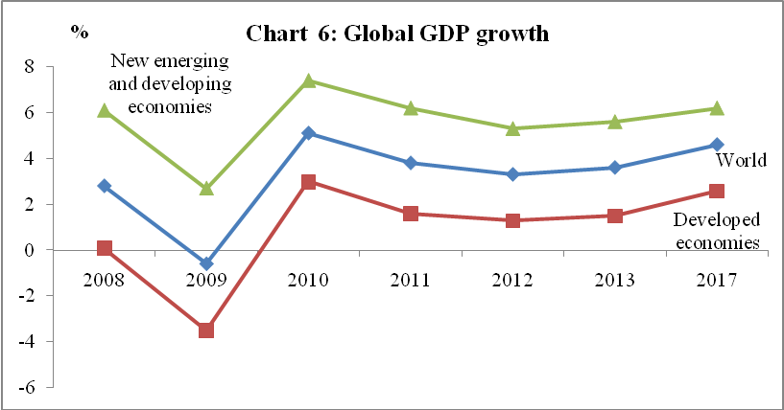

Source: IMF2012/2013,'WEO 2013', November 2012 and April 2013.

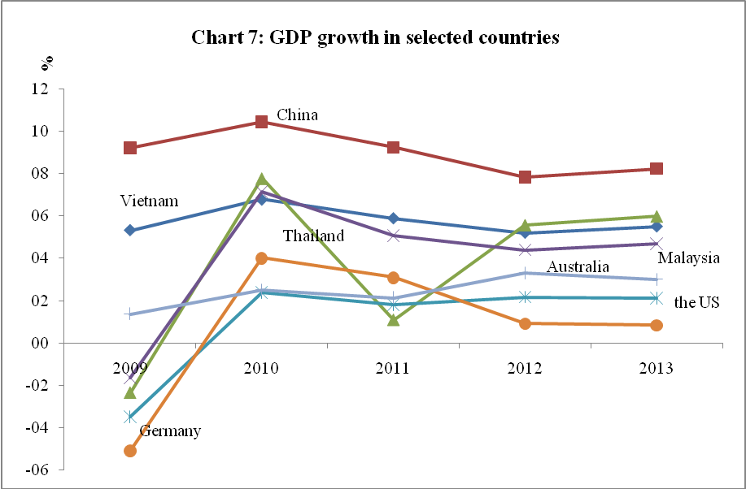

Source: Compiled from WEO2013 and GSO's statistics yearbooks 2009-2012
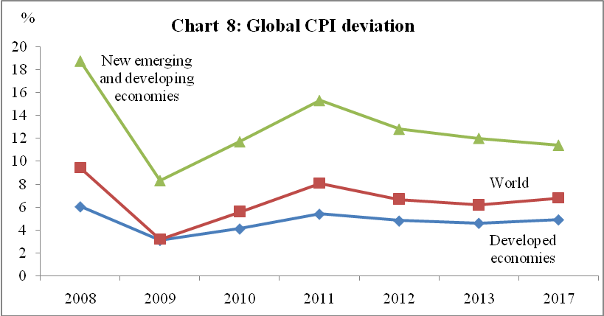
In regard to inflation, pressure of global inflation is expected to be eased owing to the sluggish global production outlook (fall in demand for goods and services in Chinese and Indian economies), downscaling speculation and oil price, those factors would reduce markets’ demand, and then general price level of the global economy. Expected inflation will be at 3.25 percent instead of 3.5 percent of year 2012, in which CPI of developed economies will rise 1.7 percent (the US 1.8 percent, EU 1.7 percent), and the other side, new emerging and developing economies will hike at 5 percent. In such circumstance, oil shocks and food price shocks owing to political upheavals and natural disasters remain about to occur.

Source: IMF’s WEO 2013, April 2013

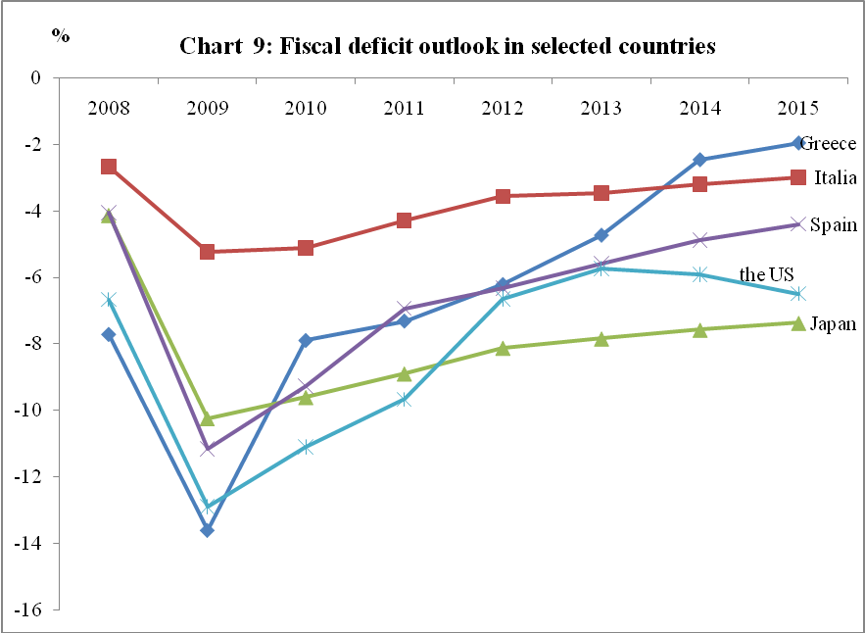
Extensively, employment status and oil shocks owing to recessive supplies, and Middle East tensions, monetary system and European public debts causing potential financial crisis etc, remain potential. In dealing with pressure of slow growth, risks of financial crises, unemployment, and inflation, almost all countries favourably would execute tightened fiscal policy, monetary policy with quantitatively easing (QEs) and build policy trust in the public eyes, which shall foster and sustain macroeconomic essentials.

Source: IMF’s WEOs2012/2013, October2012and April 2013
1.2 Domestic economic outlook 2013
The 2013 domestic economic outlook will experience different advantages and disadvantages among other externalities. Factors that favor economic stability include constrained inflation, outperformance of encouraging government's production-backed policies commences, low credit interests to firms and citizens, and manufacturing growth restoration. However, eye-sighted challenges can be pro-tracted. Major macroeconomic imbalances are predicted; demand for goods and services is low, high stock of goods (particularly real-estate stocks and construction materials); bad debts in a fragile banking system; competitiveness of goods and services is drastical and affected by interrelated global factors (i.e, a contraction of foreign direct investment inflows, global economic dip-recession, and latent risks of financial crises).
Master Objectives of Socio-Economics 2013
Principal socio-economic indicators which have been set in the 2013 socio-economic development plan are (i) GDP growth is expected to crossover 5.5 percent of year 2012, of which added value of agriculture sector will increase 2.3 percent, manufacturing and construction sector 5.7 percent and services closely 6.5 percent; (ii) inflation to be controlled at a range of 7-8 percent; (iii) exports turnover will grow 10 percent; (iv) new job creation of 1.59 millions of people; (v) fiscal deficit will be upholding at 4.8 percent of GDP; (vi) assure spare resources for the entire social investments at 29.7 percent of GDP (public investment is of 17.9 percent); (vii) add up more accrued savings against consumptions to 31.6 percent.
Table 4: Socio-economic indicators 2009-2013 %
No. | Major targets | 2009 | 2010 | 2011 | 2012 | 2013
1 | Real GDP growth | 5,32 | 6,78 | 5,89 | 5,03 | 5,5
2 | CPI | 6,52 | 11,75 | 18,13 | 6.81 | 8,0
3 | Gross social investments over GDP | 42.7 | 41.9 | 34.6 | 28.5 | 29.7
4 | Exports value growth | -8,92 | 26,52 | 34,15 | 18,2 | 10,0
5 | Trade balance | -22,5 | -17,4 | -10,2 | +0,7 | -8,0
6 | Poverty rate | 11,3 | 9,45 | 11,76 | 9.64 | ↓2%
7 | Urban unemployment rate | 4,60 | 4,29 | 4,51 | 3,25 | 4,47
Source: GSO, Vietnam Stastical yearbooks. Those 2012 statistics are on the the government’s supplementation report to socio-economic review at the session V of the National Assembly Term XIII (May 2013).

2. Government Budget Plan 2013
2.1. Master objectives 2013
Economically, in the context of the above global economic and domestic socio-economic developments could determine the 2013 master economic targets, the crucial middle-year of the Five Year Socio-Economic Plan 2011-2015, which are enhancing macroeconomic stability, restraining preventive high inflation, sound economic growth target, restructuring economy, insuring social security, national defense and security and sovereignty, foreign affairs and so on.
Fiscally, restructuring government budget compositions are proceeded; strictly management, savings and effectiveness of countrywide resources, securing national finance system are enhanced, which will actively contribute to economic viability, curb inflation; further more, social security and national defence, public security and foreign affairs are enhanced furthermore in the coming era.
2.2 Plan of Government Revenues 2013
Total general government revenues are projected at 816 trillion dongs, increasing 9.8 percent relative to the 2012 realised number’s. In which, the domestic revenues (excluding revenues from land user right assignment revenues and state-owned houses liquidation) over GDP ratio will reach 15.0 percent, keeping a same pace over past few years.
2.2.1 Domestic revenues are expected to attain 545.5 trillion dongs, raising 14.4 percent in relation to that of year 2012; if eliminating revenue from land user right assignment (39 trillion dongs), domestic revenues remain 506.5 trillion dongs, 19.9 percent higher than that of 2012 performance; or if further excluding those delayed tax payments of year 2012 to 2013 of 4.5 trillion dongs and a reduced mount of 5.2 trillion dongs revenues affected by the revised Law of Personal Income Tax (2012) which shall take effect from July 1st 2013, the domestic revenues will only gain 17.6 percent over 2012; of which, portion of state-owned enterprises reverences are projected to gain 21.3 percent; foreign invested firms 29.5 percent, revenues from nonstate sector gain 28.4 percent; registration fees 13.7 percent, environmental protection (includes petroleum fees) rises 12.7 percent. Among the context of 2012 domestic revenues were reviewed to be lowered than the budgeted numbers, in line with 5.5 percentage GDP growth target and CPI 7-8 percent in 2013, the budgeted domestic revenues 2013 are relatively high, will inquire more effort of execution and management.
2.2.2 Revenues from oil production are budgeted to reach 99 trillion dongs, comprising those revenues incurred in 2013 of 89 trillion dongs with an expected oil production volume of 14.14 million tons by the Vietnam PETRO group and averaged price at around 90 USD/barrel; extra profits from oils and natural gas of host country (Vietnam) recollected from year 2011 backwards 10 trillion dongs.
2.2.3 Total revenues from exports and imports is projected at 237.5 trillion dongs, an extra gain of 20.0 percent relative to that of 2012; after netting 71 trillion dongs of VAT refunds, remaining 166.5 trillion dongs, 30.3 percent higher than that of year 2012 performance. This budgeted number is calculated on a basis of exports value expects to increase 10.0 percent over the year 2012, trade deficit over exports value predicts at 8.0 percent, and also some factors decreasing revenues (i.e. tariff cuts under global integration roadmap etc) have been taken into account.
2.2.4 Revenue from grants is expected to increase 5 trillion dongs in 2013, an equal amount of the year 2012’s.
2.3 Plan of Government Expenditures 2013
2.3.1 Major directive policies on government expenditures
In the first place, the government budget continues to be restructured towards securing citizen's needs and social security, giving resources to development and investment connected to restructuring public investment, enhancing education expenses, science and technology, healthcare, environmental protection, culture, and other crucial programs, major projects under resolutions of the party and national assembly.
Secondly, budget allocation will be focused and sure resources channeled to carry out policies’ necessities and thoroughly current expenditures to save more.
Thirdly, the 2013 budget plan will set aside contingencies, national strategic reserves in order to actively prevent, counter, recover those consequences driven by natural disasters, diseases etc., under ongoing regulations and debt repayments under commitments to be assured.
The complete budget spending plan 2013 (including current and capital expenditures) was principally formulated on the bases of a system of allocative -spending norms of current and capital expenditures approved; and also insure social security needs, national defense needs in the coming time. Therefore, demand for spending is relatively large, requiring an additional funds of 150 to 185 trillion dongs.
Based on those directive policies, the total general government expenditures in 2013 expects to be 978 trillion dongs, an extra increase of 74.9 trillion dongs relative to the 2012 budgeted number, however it can afford about 40 percent of essential needs and this has been the lowest increase over past few years. Some sound excuses are a lower budget plan 2013 relative to year 2012’s plan and no brought forward revenues inclusion.
2.3.2 Development and investment spending is expected to reach 175.061 trillion dongs, accounting for 17.9 percent of total general government expenditures. If government bond issuance 60 trillion dongs is added up total investment and development expenditures in 2013 to 252,061 billion dongs, a portion of 25.8 percent in total budget spending or 7.5 percent of GDP. The investment spending gives some priorities to infrastructure investment for rural areas, essential public transport projects, health care projects, education projects, and other crucial projects of national defense and public security in the new coming circumstances, provides supports to social housing, credit subsidies of state-funded projects and tuition-aided policy to poor students loans, and national target programs; strategic reserves to counter and relief national disasters and climate changes.
2.3.3 Repayment of debts and provision of grants in 2013 is budgeted at 105 trillion dongs, an extra increase of 5 trillion dongs compared to that of 2012 budget plan; in order to timely repay internal and external debts as committed.
2.3.4 Current expenditures in 2012 are budgeted at 658,839 billion dongs, 7.9 percent higher that that of 2012 actual number. In which, 15.6 trillion dongs is allocated to adjust minimum wage to 1.15 million dongs per month. For that budgeted plan, the allocated funds for current spending can only meet two thirds of the 2013's needs. According to directive policies, current expenditures are given priorities to major crucial items under the Party and the National Assembly's resolutions; save 10 percent of current spendings of 8 trillion dongs at the right budgeting point (excluding those funds are given to salaries, job allowances and social benefits to the merited people), of which central government budget retains their savings (1.8 trillion dongs) out of allocative funds to inline ministries, central agencies and local governments keep their savings (6.4 trillion dongs) out of the allocated funds to their spending agencies and spending units. These savings will be used to enhance the implementation of social security policies, particularly new issued policies (The Ordinance on the merited people, management policies, and paddy crops land, lunch boxes for children aged 3-4 etc). The miscellaneous spending assignments needed to cut down, and allocated as lower than demanded.
2.4 Government budget balance 2013
Owing to limited capability to balance the 2013 budget, budget deficit is proposed by the government to keep at the same ratio as of year 2012, which is at 4.8 percent of GDP (162 trillion dongs), giving more resources to capital development and investment. However, if being deducted debt principals repayments, the deficit rate is only about 3 percent of GDP, reaching above the average level in comparison to other countries in Southeast Asian region.
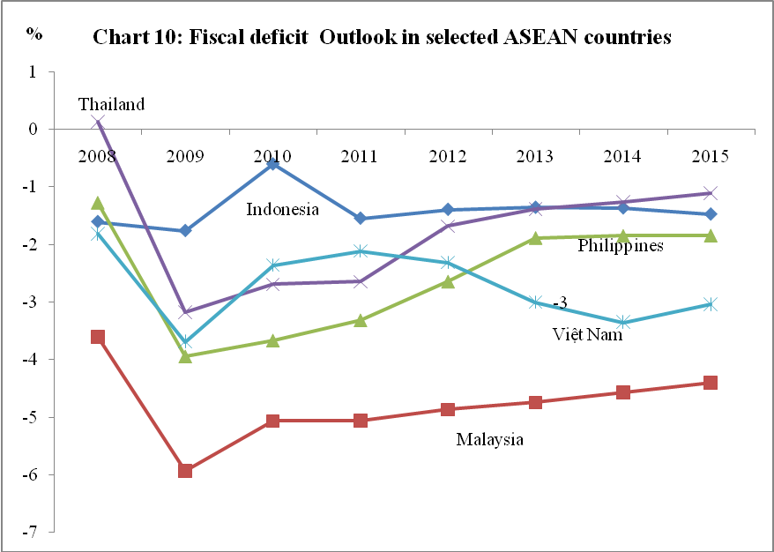

Source: Asian Development Outlook, May 2013 and Mof2013. The deficit number of Vietnam is calculated based on the GFS standards, in which principal repayment was excluded.
Public debt projection 2013: the 2013 outstanding public debt is expected at 56 percent of GDP, outstanding governmental debt of 43.5 percent of GDP and outstanding national debt of about 45.2 percent of GDP. Therefore, these ratios remain below public debt’s safety limits under the Public Debt Strategy. Meanwhile, some public debts targets are also required in the Strategy, which are public debt outstanding to reach a safety threshold of 65 percent of GDP, governmental debt stock less than 50 percent of GDP, national debts outstanding less than 50 percent of GDP. Following those targets it is required that expectations of government deficit in 2014 and 2015 must be reduced to below 4.5 percent of GDP written in the Party and in the National Assembly's future resolutions as higher economic growth resumes.
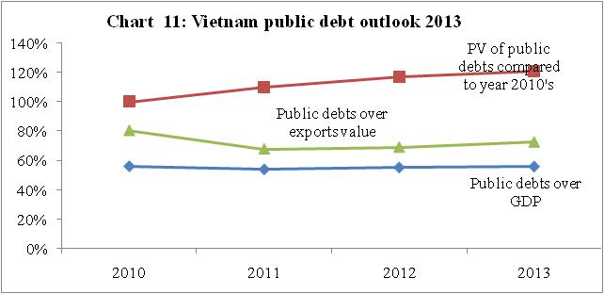

Source: MoF2012, Department of Debt management and external finance

Moreover, PDA(2012), the World bank and the IMF have confirmed that Vietnam's public debt remains below safety limits, the public debts over exports value was much below 150 percent, even more revenues are always insured to grow year-to-year, and reasonably debts repayments are sustained.
Chapter III. The 2013 Budget Plan’s Developments

1. The 2013 Budget Plan’s Developments
1.1 Fiscal Measures Performance to ease Firms’ Production and Business, to support Markets and to tackle Bad Debts
To achieve master objectives and tasks of soci-economic development in 2013 under the National Assembly's Resolutions which are inflation controlling, macro-economic stabilizing, social security ensure, gradually implementation of restructuring economy towards improving quality, efficiency and competitiveness; creating a change from the early months of the year, striving to achieve the highest level of socio-economic development indicators in 2013; at the same time, fiscal measures to overcome economic difficulties and create favorable conditions for enterprises to restore their production-business, bad debt resolving associated with aiding market developments were promulgated; the government has focused on directing, implementing those aligned and efficient technical-economic solutions, credit, finance - budget, promoting trade and investment and so on so forte to solve difficulties for business-production, markets assistance and bad debts resolvings. Of which, financial-budgetary measures are made as follows:
1.1.1 Investment measures
Urgently complete the allocation of investment capital; focus on accelerating implementation and disbursement of investment capital for projects and programs in 2013; intensify the implementation of the plan by investors and tackle delaying in completing procedures on investment, purchasing and in acceptance stage, capital payment. Allow to extend time and payments made ​​for the plan 2012’s capital projects which were sourced from (i) central government budget’s contingent budget and (ii) the 2011 central government budget’s surplus, (iii) the plan 2013’s advanced capital will be executed until June 30, 2013. In addition, the an extra VND 10 trillion allocation for investment credit programs on solidification canals, development of rural roads, infrastructure, aquaculture and rural village infrastructure has been made.
1.1.2 Budget revenue measures
Government has urgently issued guidelines and executed tax exemptions, tax payment delay and tax reductions, and other revenues relaxation for businesses, organizations and individuals in dealing with troubles, revised tax administration procedures to facilitate businesses.

Corporate income tax measures
- Extend 06 months the deadline of those tax payables due in QI/2013 and 03 months of the deadlines for those tax payables due in QII, III/2013 by small and medium-sized businesses, by more-than-300 laboured enterprises specialising in production, processing or processing of agricultural, forestry and aquatic products, textiles, footwear, electronic components, construction of socio-economic infrastructure investment enterprises, social housing investment business activities.
- Propose to the National Assembly the revised Law on Corporate Income Tax; of which, it is expected to specifically introduce on small and medium-sized businesses with tax rate of 20%, and incomes from social housing investment projects firms with tax rate of 10% from July 1st, 2013 (06 months earlier than the scheduled itinerary by the revised law).
Concerning value-added tax measures
- Extend 06 month of the deadlines for those tax payables due in January, February, March 2013 by small and medium-sized businesses, by more-than-300 laboured enterprises specialising in production, processing or processing of agricultural, forestries and aquatic products, textiles, footwear, electronic components, construction of socio-economic infrastructure investment firms, and by those firms who are following a tax deduction method produce steel, iron products, cements, tiles etc.,.
- Propose to the National Assembly the revised Law on Value Added Tax; of which, reducing 50 percent of the output tax from 01/7/2013 to June 30th, 2014 for social housing investment business activities.
Environmental protection tax measures
Make refunds of tax paid between January 1st, 2012 to November 14th, 2012 for those ready packing nylonised-bags under provisions of the Decree No. 69/2012/ND-CP dated 14/9/2012 of the Government.

Vehicle registration tax measures
Impose a general bireme of 10 percent for passenger cars under 10 seats for whom has first registration (localities can flexibly increase their registration tax rate to a specific level but must not exceeding 50% of the general bireme), from 2nd registration onwards, tax rate is 2 percent and to be implemented uniquely across the country. At the same time, policies on personal vehicle limiting charges are discarded.
Land rents measures
Reduce 50 percent of those land rent revenues to be paid in 2013, 2014 for economic organizations, households and individuals who suffering a double 2010’s renting rate as regulated under provisions of the Decree No. 121/2010/ND-CP of the Government dated December 30th,2010. In case, these rents, after being reduced still greater than 2 times of rent payables in 2010, shall be reduced to the level of rents that equals 2 times the amount of rent to be paid in 2010. At the same time, project investors who have not fulfilled payment of the land user right granting fees owing to financial troubles are allowed to pay land user right granting fees by actual sale of houses within a maximum duration of 24 months from the date of payment notifications by tax authorities. On the basis of the ability to balance local government budgets, provincial people's committees can consider and decide the time extension of paying land user right fees for each project after reporting to the same level standing people’s councils.
1.1.3. Resolving bad debts
Government has developed and implemented solutions for dealing with bad debts of state-owned enterprises during the process of restructuring state-owned enterprises under the project "Restructuring state-owned enterprises, focusing on economic corporations and general corporations in the period 2011-2015”, which was approved by the Prime Minister in Decision No. 929/QD-TTg on July 17th2012; to develop mechanisms and options to solve non-performing loans of the Social Policy Bank and of the Vietnam Development Bank, and nonperforming loans lending to state policy objects, bad debts of state-owned enterprises; and to revise regulations in order to form a legal framework for establishing and developing markets of purchasing debt instruments.
Because of time limits during implementing the above solutions, it has been insufficient evidence to assess the full impact of those policies on economic activities, but we may find the solutions proposed is essential and is the first step to create positive changes for businesses and investors.
1.2 The 2013 Budget Plan’s 4 month performance
The 4 month socio-ecnonomic developments have show positive signs of recovery compared to the year 2012 thanks to good performance of directing measures by Resolutions 01/NQ-CP and 02/NQ-CP of the government on supporting solutions to recover and stabilise production and business, price controlling. Major economic indicators have outperformed over last year, of which GDP grows at 4.89 percent in Quarter I/2013, industrial production index increases 5.0 percent, exports turnover rises 16.9 percent, imports values 18 percent higher, gross retails of goods, sales of services and consumption hikes 12 percent etc.,; lower market interest rates, improved banking system’s liquidity, exchange regime and exchange markets kept stable; inflation reined and lowered than the same period of 4 preceeding years…Nevertheless, numbers of challenges are awaiting forwards, particularly the lower credit growth; farming production faces seasonal droughts, seawater overwhelmed farming lands; some specific sectoral firms’ production and business remain difficult; consumption of goods and services is low due to poor purchasing power; real-estates market remains unrecovered etc,; while potential risks of natural disaters, diseases remain challengeable. Such economic developments have affected the budget exectution during early 4 months of 2013. More details are as follows:

1.2.1 Government budget revenues
On-budget government revenues have been estimated at 244.1 trillion dongs for 4 months, an equivalence of 29.9 percent of the budgeted number, an increase of 2 percent over the same period last year. Of which:

Domestic revenues’s estimate is at 164.29 trillion dongs, completing 30.1 percent of the budgeted number, rising 2.9 percent over the same period last year, reaching lower levels of plan completion and the growth rate as compared to recent years. As assessed, though there are 9 out of 14 revenues, tax collection reaching and exceeding the level of performance of same period last year, they actually are small portions of the government budgets (i.e. registration fees, charges; sales of state-owned houses, and miscellaneous revenues); there are 5 big revenues lower than the same period last year in which large revenues are revenues from state sector (89.1 percent), personal income tax (96.2 percent) and land user right granting revenues (76.4 percent). Main drivers for this can be found, such as low developments of production and businesses, lower purchase power, lower economic growth than expected owing to a gain in services sector with small rate of budget mobilisation, the industrial sector with a large portion of budget mobilisation are slowly recovered; the revenues from Quarter IV/2012 to Quarter I/2013 as regulations reduced greater than 13 trillion dongs over same period last year driven by low performance of production and business activties of many firms.

Oil revenues reaches 40.27 trillion dongs, completing 40.7 percent of the bubgeted number, increasing 4.6 percent over the same period last year. Averaged payment price of oil reaches 115 USD/barrel, an extra rise of 25 USD/barrel higher than projected price and the trading volume reaches 4.85 million tons, completing 34.3 of the plan.

Revenues from export and import activities attain 56,290 billion dongs, completing 23.7 percent of the budgeted number, reducing 5.3 percent over the same period 2012. After netting 18 trillion dongs of VAT refund, the net revenues remain 38.29 trillion dongs, completing 23 percent of the planned number, declining 4.3 percent over the same period last year. Total exports turnover of early 4months of 2013 primely upholds a rapid growth over last year’s same period (exports rise 16.9 percent and imports rise 18 percent). Despite the good growth, exports and imports with high-valued items and high tax rates which account a greater revenues are very low (i.e. automobiles, the complete imported motobikes, petrol...). Besides that, the downward adjustment of tariffs of imports on some items to favor domestic productiosn has also caused the lower budget revenues.

1.2.2 Government budget spending
Total general government expenditures attain 303.4 trillion dongs, completing 31 percent as planned, of which: development and investment spending completes 32.6 percent as planned; debt repayment and grants provision complete 32.6 percent of the budgeted number; current expenditures complete 32.2 percent of the plan.

The organization of budget execution in 2013 was developed positively, proactively. Though revenues are lower in the first few months, but the spending tasks and project timing progress of investors and spending units are insured as planned; requirements of administration of national defense, security and operation of the state apparatus and timely demands ensuring social security are fully met. Capital disbursement progress in four months (both on-budget funds and government bond issuance funds) are also better than the same period in 2012, in which the government budget disbursement reaches approximately 32 percent of the plan (the same period last year was 14 percent); capital investment from government bonds is estimated at 31 percent of plan (same period last year reached about 5 percent).
As of April 2013, nearly 615 billion dongs of central government budget’s provisions was used to perform remedial tasks of nature disasters, epidemics and to support local agriculture recovery. Besides, about 38 thousand tons of rice of the national strategic reserves has made ​​in relieving life of people who suffer from hunger in the poor regions, seasonal crop exchanges’s losses, positively contributing to social welfare policies.

1.2.3 Government budget balance
The 4 month budget deficit is estimated at 59.3 trillion dongs, completing 36.6 percent of plan. As of April 25th 2013, about 82.69 trillion dongs of government bonds was issued to offset the deficit and for investment and development spending, accounting for 42.4 percent of mobilizing domestic capital in 2013.

2. Challenges need solved to the 2013 budget plan execution
2.1 The world economic developments
The world economic environment stays potential risks and uncertainties. Pacing into 2013, the world economy has shown signs of recovery, but not significant and uneven across regions; purchasing governance index Management (PMI) reflects a slightly downward trend of the productivity of the global industries; debt problems and budget deficits continue to cause concerns for some membered states of Eurozone, world market prices of some key commodities (oil, gold etc.), are expected to be further complicated as an upward trend. Besides, local political conflicts in the Middle East, in East Asia and the tensions on the Korean peninsula are recently expected to have a major impact on the development of the world economy and regions... In this context, many governments continue to implement an easing monetary policy to support growth. According to the World Bank (WB), the global economic environment remains fragile and could be more worse, as her forecasted, global economic growth in 2013 will be only about 2.4 percent; international Monetary Fund (IMF) predicts more positive with economic growth of about 3.3 percent, of which developing countries economies will have a growth of 1.2 percent, the developing countries in Asian region to grow by 7.1 percent, the countries of Central and Eastern of European region will grow by 2.2 percent etc.

2.2 Domestic Production and Business Developments
Despite those positive signs, the economy does not show a good recovery and contains many risks, such as fragile macroeconomic factors, low economic growth, slow performance of business activities, production obstacles due to high input costs, slow consumption, low access to credit and capital absorbance; weak purchasing power, less jobs and lower income and others, which creates greater pressure to outperform objectives of socio-economic development in 2013.

Regarding financial-budget activities, the budget plan’s 4-month performance outcomes show a very difficult situation. The progress of 4-month government budget revenue is lower than the plan’s requirement (according to the plan, month revenue on average should reach 68 trilion dongs/month, while 4-month performance of revenue averaged at 61 trillion/month, 7 trillion dong/month less than required. Therefore, to complete 100 percent of the plan, the next 8-month revenues must be closely 572 trillion dongs, or an average of about 71,500 billion/month); revenue growths in both the domestic revenues and customs revenues are low if compared to the 2012’s (as it was required in the plan, an increase of 20 percent should be gained in comparison with that of 2012’s; the 4-month revenue actuaries from 2 sectors are approximately equalling or lower than the 2012’s same period). Without decisive direction and management, reduction in in 2013 revenues is expected.

3. Major Measures to maintain budget balance and best fulfillment of the 2013 budget plan.
In the first place, greater efforts are concentrated to overcome difficulties and promote the development of production-business, speeding up the sale of goods, striving to achieve the economic growth target, thereby more social resources will be mobilised in government revenues
(1) Resolutions of freeing inventory, measures on credit loans and lending interest rate etc., are continually implemented as required by the Resolutions of the Government 01/NQ-CP and 02/NQ-CP on removing difficulties for enterprises and creating favourable conditions that can spur more investment and promote the development of production – business and resolve non-performing debts. At the same time, to review and preliminarily assess the implementation of the resolutions mentioned above in the first 6 months of this year so as to adjust or supplement more suitable solutions in the last 6 months of 2013; Strive to increase economic growth in 2013 by 5.5 percent as set out in the National Assembly’s resolutions, creating motivation for the completion of the government budget revenues in 2013. Details as desbribed:

- Monetary policy instruments are proactively used in close collaboration, synchronization with fiscal policy to strengthen macro-economic stabilit and control inflation and boost up economic growth; continually reduce the difference between deposit bank rates and lending rates at a reasonable level, boost lending to priority sectors to remove difficulties for production - business. Drastically implement Project of Restructuring credit organizations period 2011 - 2015 and accelerate resolving NPLs in the banking system, increasing more available credit to the economy, creating more resources in the government budget revenues.

- Continue to promote the reform of administrative procedures related to production-business investments, particularly those procedures relating to credit loans, taxes, customs, real estates, business registration etc., to exploit resources for developments. Implement measures to support, to encourage exports and to boost service exports and in-place export to increase foreign exchange earnings for the economy; supporting businesses to increase frequency of goods deliveries in the region rural and remote areas to stimulate consumer demand in rural markets, thereby reducing inventories.
Second, continue to review and improve revenue policies; enhance the management of government budget revenue, reduce losses, handle outstanding tax debts, fulfill the highest level of government budget plans’ revenues.
(2) Review, improve mechanisms and policies towards encouraging domestic production and protecting natural resources, which can create reasonable revenues mobilization, preventing revenue losses. Among them:
- Continue to implement the roadmap of market values, remove price-subsidies for some goods and services (electricity, coal for electricity, gas, public services). On that basis, timely adjust imports tariffs on petroleum as market price movements, keeping priorities on imports tariffs to ensure budget revenues, restricting the petroleum smuggling across the borders. At the same time, a policy of social security supporting for those policies’s beneficiaries, the poor people, the difficult people have been made.

- Review and adjust the management policy of imports consistent with the actual situations, to facilitate production-business and investment attraction.

(3) Strengthen guidance and administration of local authorities in collaboration with industries to improve the quality of revenue management. Make checks to grasp revenues’ objects in the areas, strive to collect revenues at the fields, industries, localities which are able to increase revenues, to offset the revenue decreased due to implementation of policies on tax exemption, tax reduction, deferment of tax payments. Strengthen inspection, tax inspection combined with inspection and checking implementation of law on prices; Put comtrol on tax declaration and tax finalization of businesses, organizations and individuals to ensure those correct, full, and timely collection of taxes, fees and other revenues to the government budget. Fulfill collection of revenues based on conclusions and recommendations of the State Audit Office, the agency inspectors and other law enforcement agencies.

Closely manage the tax refunds, insuring provision to right beneficiaries, the right regulations. Strengthening coordination among revenue collection agencies, financial institutions and enforcement agencies in the management of revenues, reduction of losses and arrears processing, trading frauds, smuggling, anti-price transfers.

Third, accelerate the implementation of investment and development tasks, creating a driving force for economic development; at the same time, strengthen budget expenditure controlling towards saving, strictness and effectiveness
(4) Continue to review, timely adjust mechanisms and policies which are out of date, implement measures to accelerate the schedules of construction, the disbursement of development investment with especially investment capital from government budget, government bonds, national target programs and ODA, in order to quickly restore the growth momentum of the economy, to provide revenues for the government budget, limiting firms’ tax arrears. Continue to promote the processing of capital construction arrears in localities.

(5) Actively review and rearrange current spending tasks more frequently; cut down or delay the progress of urgent tasks, expenses in equipment procurement, cars; minimize organizing conferences, seminars, national ceremonies, inauguration, announced its decision; reduction of at least 20 percent of costs of electricity, water, telephone, stationery, petrol etc.,; minimum savings of 30 percent of the budget plan was allocated to the tasks of organized festivals, receptions, conferences, seminars, internal and external business trips. On that basis, ensure the implementation of issused regulations and policies, and social security policies, minimizing additional funding beyond the plan, and also:
- To save an additional 10 percent of the expenditure estimates in the remaining months of the 2013 budget plan (excludes wages and allowances in salary and expenses for people as regulations; save 10 percent of current spending to generate resources for salary reform). As of 4th Quarter,2013 if budget situation is positive, it will continue to make payments as planned; in case, the situation is ​difficult, cuts will be made which includes savings of ministries, central agencies could be moved to the Central government budget provision for general balance purpose, the amount of local governments savings are used to offset those educed revenues or increased spending for social welfare tasks of local governments.

- Fix the overlapping, wastefulness and ineffectiveness in implementing and allocating funds to programs, projects, tasks; no additional projects, new programs and policies will be supplemented or no increase in spending norms unless unidentified sources guaranteed.
(6) Make more cuts in the budget plan, recover those funds to build up more contingent funds to the central government budget and local budgets against those capital and current expenditures assigned to the 2013’s budget plans of ministries, central agencies and localities up-to-date June30,2013 were unallocated or allocated but not prescribed as planned; and investment capitals of the 2013’s budget plan which allocated to projects but were not disbursed upto the date June 30.2013 and other funds that spending units used improperly.

Fourth, actively control budgets in line with revenue performance, ensure budget balance at all levels and keep budget deficit within the National Assembly’s approved range
(7) Implement principles which shares burdens between the central government budget and local government budget, the locals strive to increase more revenues and debts recovery to compensate for the reduced revenue caused by tax exemption, tax extension and other factors.

(8) Strictly manage the planned contingent budgets at all budget levels; controlling the spending within 50% of the contingencies which have been allocated in the budget plan of each budget level so as to handle urgent incurences, such as preventing and alleviating consequences of natural disasters, epidemics, defense, security etc., and 50 percent of the remaining provisions will be spared in case that a large revenue reduction about to occur, cutting further spending to ensure budget balance.

(9) Based on the ability to collect revenues, localities’ expenditures shall be performed in tightened, efficient and economical principles as follows:
- If local government revenues are likely to reach and exceed the assigned plan: only increase spending for some important tasks, urgent incurences (relieving the consequences of natural disasters, epidemics etc.).
- If local government revenues are lower than budgets delivered, after be implemented reviewing and rearranging spending tasks but that are still not offset amount of revenue reduction, localilties have to use their financial resources flexibly (source of wage reform, the 2012’s local budget surplus, excessive local revenues in 2012, financial reserve funds etc.,) to ensure their local budgets balanced. In which local must give priorities to payments of wages, salary and liked-salaries, current expenditures to ensure usual operations of agencies, units and social security expenditures, capital expenditures for important construction projects. Where any reduction in land user right assignment revenue compared with the plan, there have to make more ​​cuts, or rescheduling the implementation of those projects, programs whose funds are sourced from this revenue.
References
1. ADB2012, 'Asian Economics Outlook 2012', dated November 2012.
2. ADB2013, 'Asian Economics Outlook 2012', dated April 2013.
3.Gov2012, Report on socio-economic review in 2012 and socioeconomic Plan for 2013', Report no.284/REP-GOV, dated October19th, 2012.
4.Gov2012, 'Report on the 2012 government budget review and the government budget plan for 2013', Report no.285/REP-Gov. dated October19th, 2012.
5.Gov.2012, 'Report on the 2013 central government budget approriations', Report no. 286/REP-Gov dated October19th, 2012.
6. Gov.2013, Report 194/BC-CP dated May 17,2013 on supplementarily review socio-economic developments of the 2012 plan and the 2013 plan
7. Gov.2013, Report 197/REP-GOV dated May 18,2013 supplementarily review government budget developments of the 2012 plan and the 2013 plan
8. Gov 2012, Resolution on 'Some major measures to alleviating difficulties for production, business activities and markets', Resolution no. 13/RES-Gov dated May 10,2012.
9. GSO2012, 'Vietnam Statistics Yearbook 2012'
10. IMF2012, 'World Economics Outlook 2012', dated October 15, 2012.
11. ILO2012, 'Report on global employment trends', April 2012
12. ILO2013, 'Report on global employment trends', April 2013
13. IMF2012, 'Debt sustainability Analysis', Article IV/2012 report
14. IMF2012, 'Government Financial Statistics 2012' .
15. NA2012, Resolution no 31/2012/QH13 dated November 8th 2013 on the approval of the 2013 socio-economic plan.
16. NA2012, Resolution no 32/2012/QH13 dated November10th 2013 on the approval of the 2013 general government budget plan.
17. NA2012, Resolution no 33/2012/QH13 dated November10th 2013 on the approval of the 2013 central government budget plan.
8.NA2011, Resolution on 'Socio-economic five-year plan for 2011-2015', Resolution no.10/2010/QN13 dated November 8, 2011.
19.NA2012, Resolution on ' promulgating some tax policies in order to alleviating difficulties for businesses and individuals', Resolution no.29/2012/NA13 dated June 21, 2012.
20.PM2011, Decision on 'reducing land rental in 2011 and 2012 economic businesses, excluding commercial and services businesses', Decision no.2093/DEC-PM, dated November 23, 2011.
21.PM2012, Directive 30/CT-TTg dated November 26,2012 on practicing thrifty and anti-wastefulness.
22.PM2012, Decision on "Approval of Public debts and national external debts period 2011 – 2020 and its vision until 2030", Decision no. 958/DEC-PM, dated July 27, 2012.
23.PM2012, Decision on '3 month extension of corporate income tax payments that going due in Quarter I and II of year 2 011 of small and medium enterprises, labor-intensive firms", Decision 04/2012/DEC-PM dated November 19,2012.

The re-estimate by the IMF in April 2013 which replaces the April 2012’s projection.
ILO2012/2013, Global Employment Trends, April 2012 and Jan 2013
IMF 2012, International Financial Statistics, October 2012.
Resolution no.10/2011/QH13 dated November 8th, 2011 on the socio-economic five year plan for period 2011-2015; resolution 12/2011/QH13 dated November 9th, 2012 on the government bond issuance plan for period 2011-2015; Resolution no.13/2011/QH11 dated November 9th, 2011 on the system of national target program in period 2011-2015; Resolution no.14/2011/QH13 dated November 10th 2011 on the 2012 budget plan; Resolution no.16/2011/QH13 dated November 14th 2011 on the 2012 central budget allocation.
Resolution no.29/2012/QH13 dated June 21th 2012 on promulgating tax policies measures to alleviate difficulties for economic entities and individuals; Resolution no.13/NQ-CP dated May 10th 2012 on policy measures to unlock difficulties for production., business and markets; Decision no.04/2012/QĐ-TTg dated January 1st 2012 on extending 3 months of SOEs and labour-intensive firms' corporate income tax payables in quarter I and II of year 2011; Decision no.2093/QĐ-TTg dated November 23rd 2011 on deducting land rental in 2011 and 2012 for some economic entities (excluding firms doing commercial business and services provision).
This number excludes the tax delay but paid during the year 2012, ie. VAT incurred in April, May was delayed till November and December 2012.
For whom are households and citizens who doing house renting to workers, students; households and citizens who taking care of child; households and citizens who providing lunch boxes for workers to keep the service price unchanged as it done in 2011.
Including personal tax income (about 1,388 billion dongs) from 01 July to 31 December 2012 for whom have taxable income from wages and salaries and from business at level 1 of tax progressive range under Article 22 of the Law on personal income tax; income from dividends on stock market, capital contributions by financial institutions (146 billion dongs).
Of which, automobiles reduced 50 percent of quantity and closely 40 percent of values over the past year, cutting budget revenues of 13,370 billion dongs; motorbikes 43 percent and 24.3 percent respectively, reducing 880 billion dongs of revenues; values of autoelectronic parts and autoparts declined 27 percent, deducting 5,070 billion dongs of budget; values of motorbike-electronic parts and its parts declined 28 percent, deducting 2,650 billion dongs of budget.
Including remaining salary reforms after covering sufficient resources for salary adjustment as scheme, excessive local revenues after channeled to salary adjustment (if have), and financial reserves and budget remainders of local budgets in 2011 as regulated in the law of state budget.
GDP is determined at time of drafting budget for 2012. If compared to the 2012 GDP estimate, the deficit would be 4.75 percent of GDP.
Following up a public debt strategy up to 2020 and prospective by 2030 approved, up to 2015 the max accrued public debt must not exceed 65 percent of GDP, outstanding government debt 55.0 percent of GDP and outstanding national debt at 50.0% of GDP.
Consolidation of author using 'the WEO 2012' Oct 2012, "the ADO 2012", Nov.2012 and WEO2013/April 2013 and ADO 2013/April 2013
OECD 2013, OECD's Economic Outlook 2013 , May 2013
Resolution no. 31/2012/NA13 by the National Assembly section XIII on socio-economic development plan for year 2013.
Particularly, poverty rate reduced to 7.02 percent at poor districts.
revenues collection from tax and charges , fees account for 22.6 percent of GDP.
For period 2006-2010, accounting for 14.1 percent of GDP; in 2011 and estimate of year 2012 are 14,9 percent of GDP
At budgeting time, the 2012 domestic revenues were reviewed at higher level, therefore 2013 domestic was projected to increase 14.4 percent over 2012’s estimates.
At budgeting time, the 2012 state-sector revenues were reviewed at higher level, therefore 2013 state sector revenues were projected to increase 14.5 percent over 2012’s estimates.
At budgeting time, the 2012 foreign invested sector revenues were reviewed at higher level, therefore 2013 foreign invested sector revenues were projected to increase 16.4 percent over 2012’s estimates.
At budgeting time, the 2012 non-state sector revenues were reviewed at higher level, therefore 2013 non-state sector revenues were projected to increase 20.9 percent over 2012’s estimates.
Petro Vietnam submitted to the Prime Minister an official letter no. 5699/DKVN-HĐTV dated July 20th, 2012, and one another no. 6734/DKVN-KH dated August 24, 2012 to the NA's committee for finance and budget, by then, the 2013 crude oil production planned at 16 million tons in which domestic production of 14.14 million tons, outsourcing production 1.86 million dong. the 2013 plan included fully amount of 14.14 million dongs, and the outsourcing production acter taxes payment at foreign countries, the profits will pay tax in Vietnam in kind of corporate income tax and in domestic revenues and not in crude oil revenues
At present, forecasts are proposed that world oil price of 2013 will reduce owing to the rise expectation of oil supplies, weak demand and ambiguous economic outlook, and further affected by political developments of Middle Easts ; IMF is expecting APSP's price (avergage of Dated Brent, WTI, Dubai Fateh's prices) at 94.16 USD/barrel; International Energy Agency (EIA), WTI 90,25 USD/barrel, WB expects 103 USD/barrel
At budgeting time, the 2012 customs revenues were reviewed at higher level, therefore the 2013 budget’s was set at 14,0 percent over 2012 performance.
Resolution no.02-NQ/HNTW of the Central Committee of Party on directing the strategy for development of science and technology, in the modernisation and industrialisation till 2000; Resolution no.41/NQ-TW of the politburo on protecting environment in the acceleration period of modernisation and industrialisation of the nation; Resolution TW5 and Conclusion of the tenth Party Central Committee (session IX) on building and developing an advanced Vietnamese culture with traditionals intensified; Resolution no. 49-NQ/TW of the Politburo on the judiciary branch reform in 2020; Resolution no. 26-NQ/TW of the Central Committee of Party on agriculture, farmers and rural development; Resolution no.13-NQ/TW of the the Central Committee of Party on country's synchronised infrastructure in order to shift the country to a principal industrial country in 2020; Resolution no.37/2004/NQ-QH11 of the national assembly on education ; resolution no. 18/2008/QH12 of the NA on accelerating legal policies and socialised legislation to enhance citizens's healthcare.
Decision no. 59/2010/DE-PM dated September 30,2010 of the Prime Minister on issuing a system of current spending norms for year 2011 and Decision no. 60/2010/DE-PM of the Prime Minister on issuing principles, criteria, and capital spending norms funded by government budget period 2011-2015 and Directive no.19/DI-PM dated June 18, 2012 of the Prime Minister on drafting Plans for socio-ecnomic develoment and budget plan for year 2013 and state funded invsetments Plan for 2013-2015
About 60.8 trillion dongs of current capital was cut to offset a respective rise in capital investments under Resolution 549/NQ-UBTVQH13 dated December 18th,2012.
in the 2012 budget plan, it was set at 19.9 percent.
in the 2012 budget plan, they were 25 percent and 8.2 percent respectively
Prime Minister 2011, Decision 958/QĐ-TTg on approving public debt strategy and national foreign debts period 2011- 2020 and its vision to year 2030. The Law on Public debt management 2009 limits public debts including governmental debts, guarranteed debts and provincial govenment bonds
CPV 2011, Resolution of the the Eleventh Party Congress on the socio-economic five year plan for 2011-2015 in which targeting to gradually reduce budget deficit to below 4.5 percent of GDP, Resolution no.10/2011/QH13 dated Novermber 8, 2011.
PVs are the present value of public debts over years and converted to year 2010 to contrast, with calculated market banking interestabout 10%/year.
IMF2012, 'Debts sustainability analysis 2012', Article IV/2012 Report.
According to Resolutions 01,02 of the Government on implementing fiscal measures to tackle difficulties for businesses, facilitaing investments, promoting production and resolving bad debts.
Those are firms who employs less than 200 workers and staffs, having revenues of not exceeding 20 billion dongs/ year
The number of QI/2013; compared to that of 2012's same period, it only reached 4.75 percent.
April’s CPI increases 0.02 percent over March 2013; accrued 4 month CPI increases 2.41 percent over December 2012 (CPI of the same period in 2010 was 4.27 percent, in 2011 was 9.64 percent and 2012 was 2.6 percent).
As of March 20,2013, credit growth was negative 0.1 percent over the 2012-end.
To complete revenues as planned, 4 month-revenues must reach 33-35 percent of the plan.
Over the same period in 2010, revenues completed 34.4 percent of the plan, rose 11.8 percent; in 2011 revenues completed 36.6 percent of the plan, rose 15.7 percent; in 2012, completed 30.9 percent of the plan, rose 2.1 percent.
Of which: automobiles under 9 seats fell by 18 percent in volume, reducing 25 percent in value; motorcycles decreased 36.8 percent in volume, losing 19 percent in its value etc.,
IMF's World Economic Outlook 2013, April 2013.

